EASE VFO LSR Login

EASE VFO Login | Follow the steps below to login to EASE VFO LSR.  Step Action  1 To access EASE VFO, copy/paste or ctrl click https://ease-lsr.brightspeed.com/. (Note: Use Chrome for browser) - User Name: Enter your User Name - Password: Enter your password - Module: select Local from the dropdown - Click Login 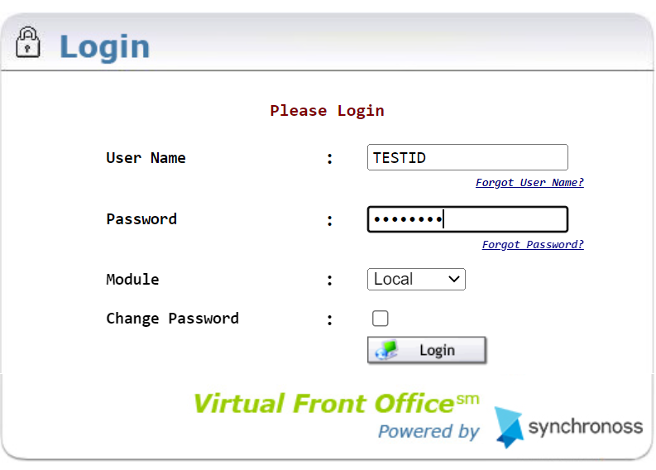 Result: Home Page/Status Screen Displays. 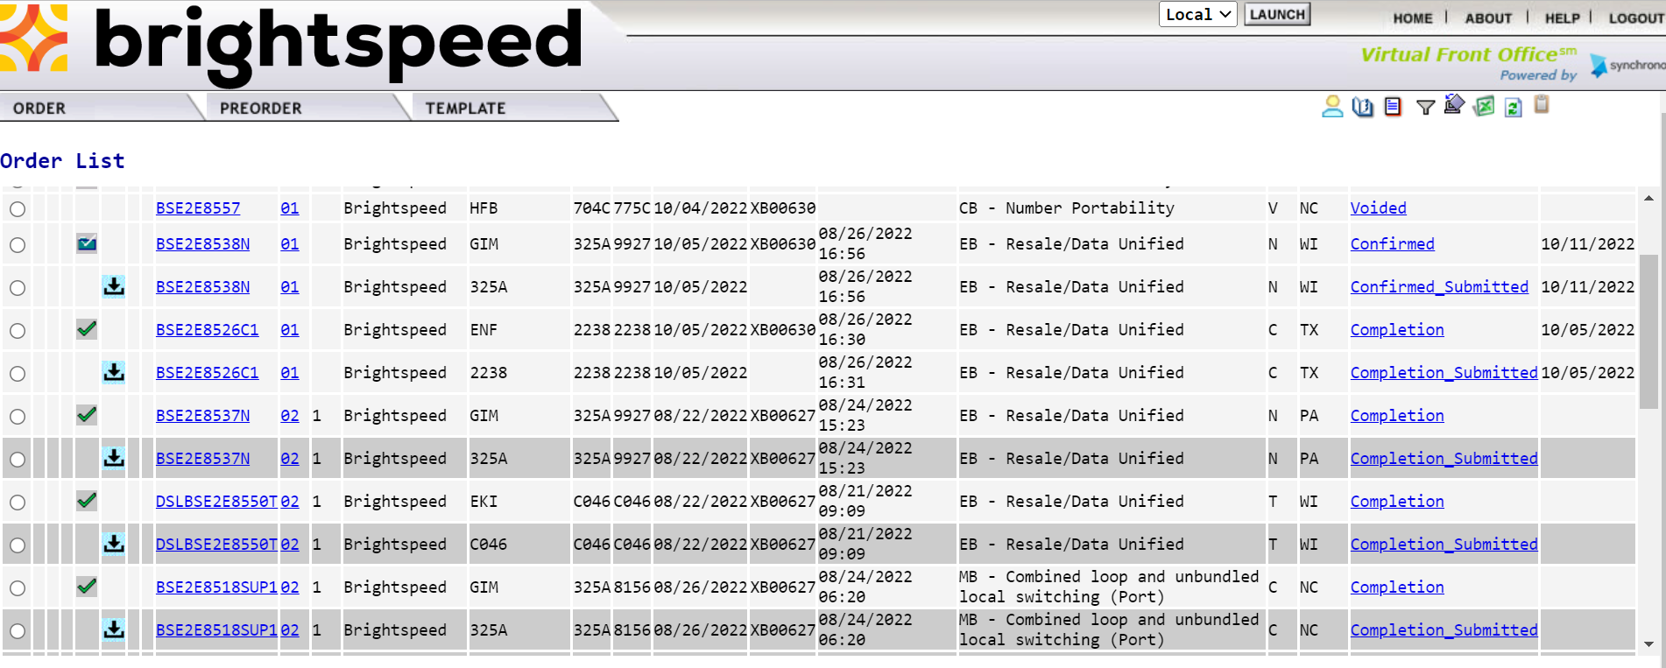

LSR Preorder

LSR Preorder | Preorder is an option that provides address validation and speed qualification. The information can be saved and retrieved later into an LSR. Follow the steps below to perform a Preorder. All entries are to be in Caps.  Step Action  1 Hover over PREORDER and click on New.  2 - Enter a Tracking ID in the TXNUM Field. (Note: This will be used to search for any saved Preorder queries.) - Select A-Address Validation from the TX Type drop down field. - Click Initiate. 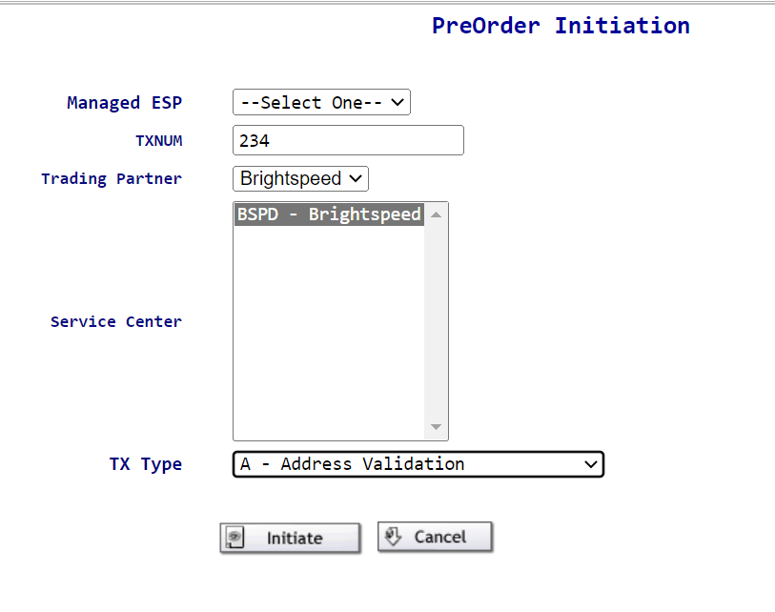

Step | Action
3 | Enter the following fields within the A-Address Validation Screen.  - STATE – Two alpha characters.  - SVC-ADDR-GRP:  - SANO – Svc Addr Number (required)  - SASD – Svc Addr St Direction Prefix (required if part of addr)  - SASN – Svc Addr Street Name (required)  - SATH – Svc Addr Street Type (required)  - SASS – Svc Addr St Dir Suffix (required if part of addr)  - CITY (required)  - STATE – Two Alpha characters (required)  - ZIP (required)  - LD/LV – Supplemental information such as unit, bldg., etc. (required if part of addr)  - Click Submit.  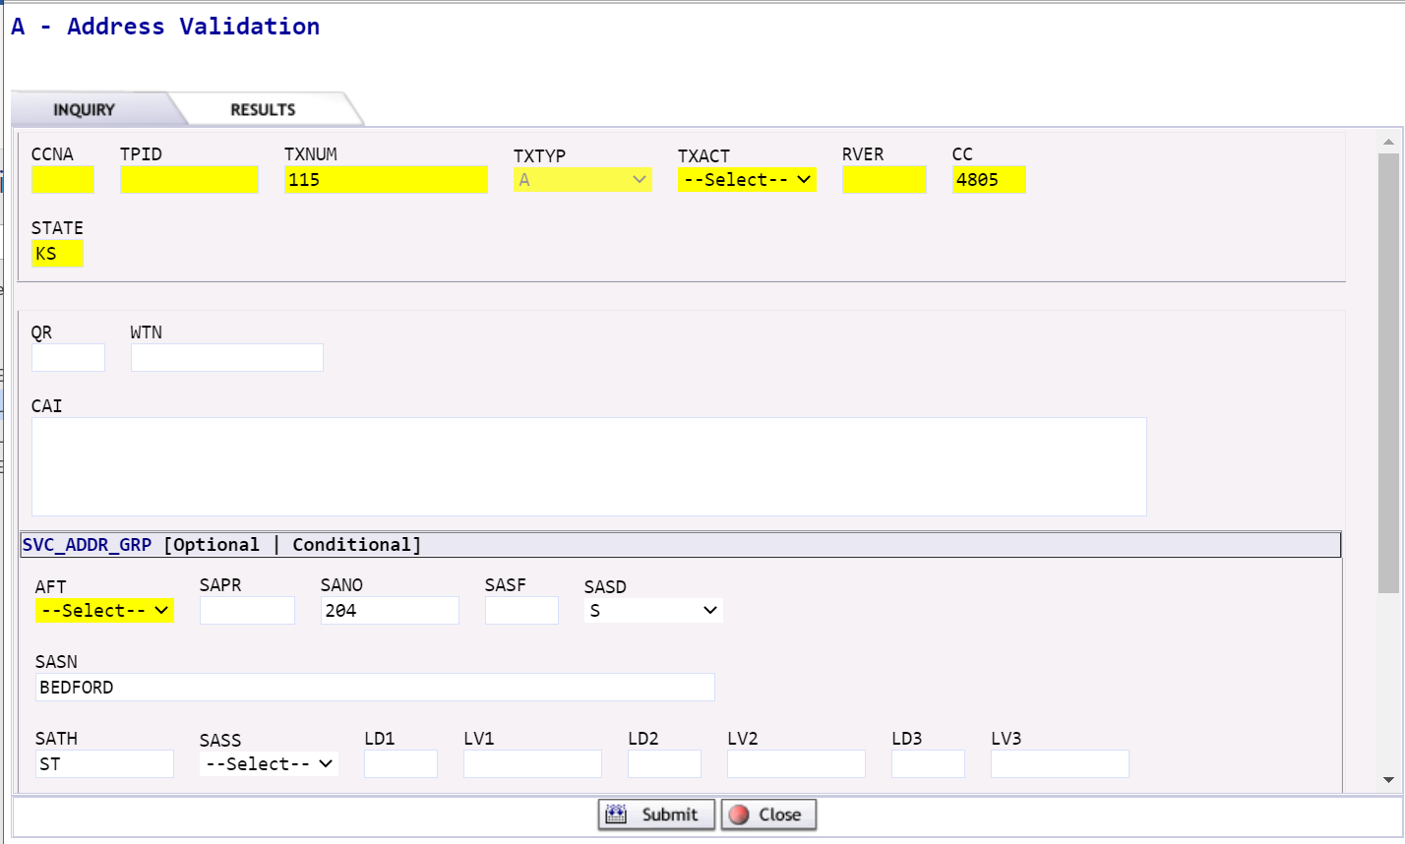

Step | Action
4 | Example of Exact Address Match Found.  - If Exact Match, Click Save.  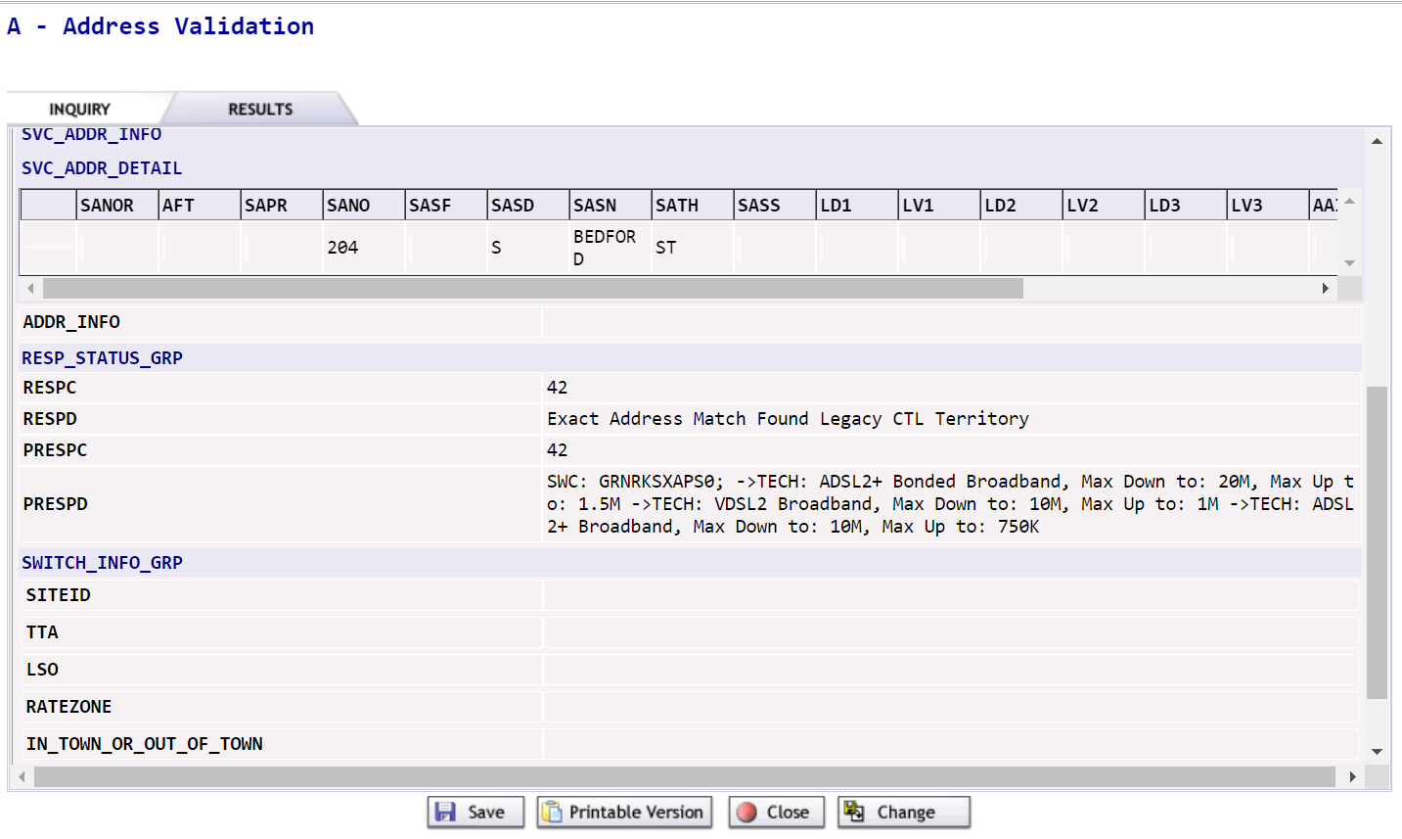  NOTE: If Near Match returned:  - Review the alternatives.  - Click on Change  - Return to step 3.

LSR New Install

LSR New Install | Follow the steps below to create and submit an LSR.  Step Action  1 Hover over ORDER and click on New. 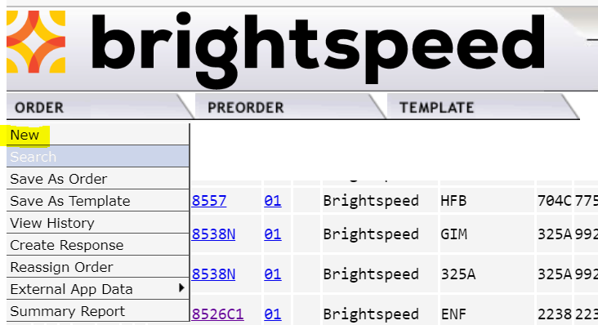  2 - Select your Managed ESP (same as OCN) - Enter your order number in Order Number field. NOTE: Must start with DSL. (example: DSL12345). - Select your OCN. - Select EB-Resale in Service Field. - Select N-New Installation in Activity field. - Click Initiate. 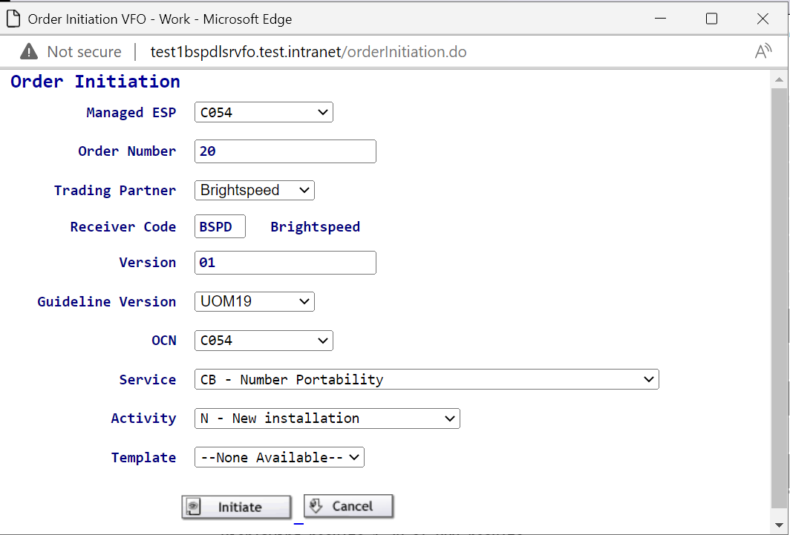

Step | Action
3 | LSR Form Entry  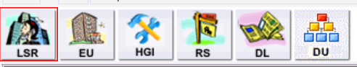  LSR Admin Section:  - Enter 1 in LOCQTY field.  - Enter your Project ID in Project ID field. Will always begin with CWS and end in BSA (example: CWSxxxxBSA)  - Select B in PROJINDR.  - Select E in RTR.  - Enter CCNA.  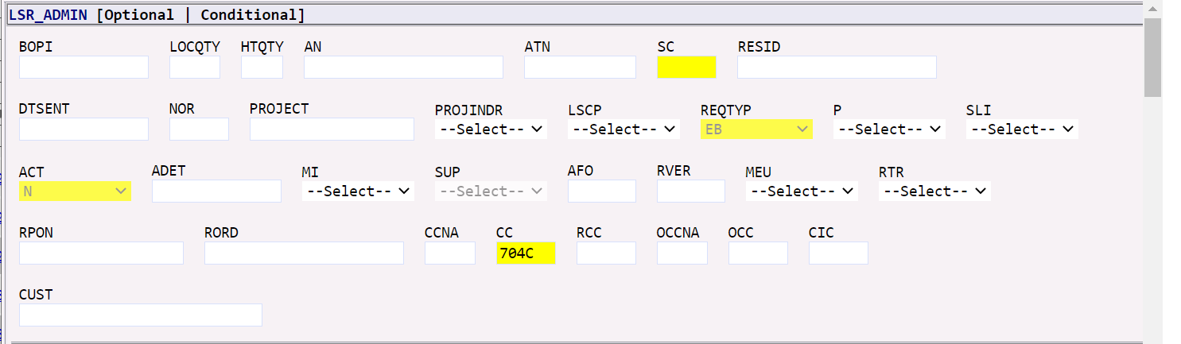

Step | Action
3 cont | LSR Form Entry (continued)  LSR Authorization section:  - Enter (1BF- for Business, 2BF- for Residence) in TOS field.  - Select DDD (Desired Due Date).  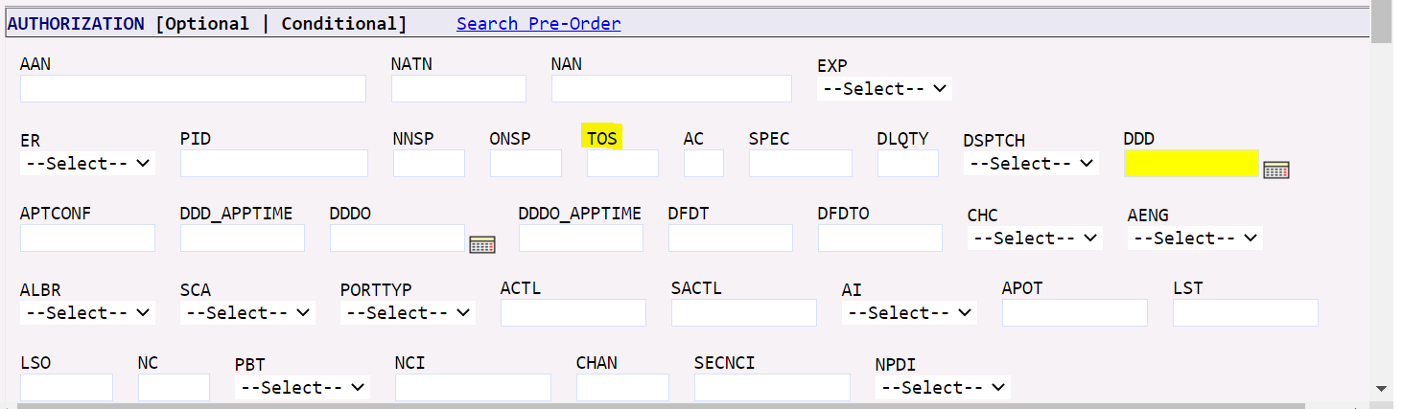  LSR Contact section:  - Enter name of person creating LSR in INIT field (to the right of the screen)  - Enter TN of person creating the LSR in INIT TEL NO field.  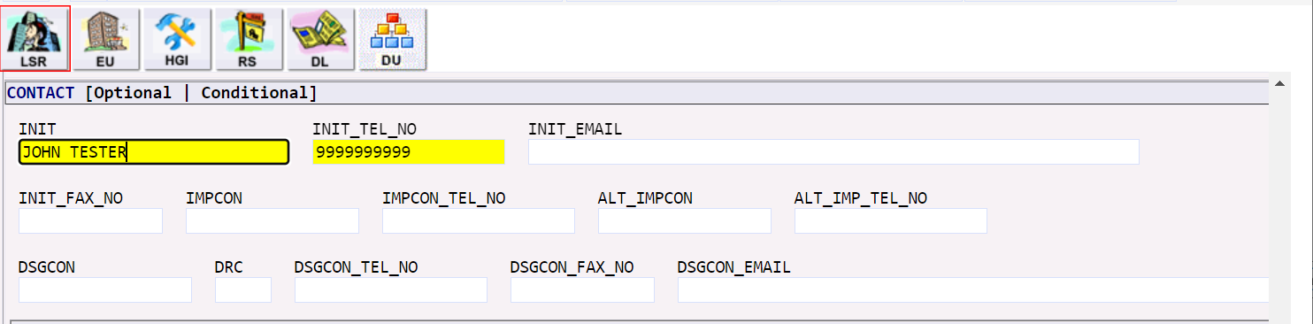

Step | Action
3 cont | LSR Form Entry (continued)  LSR Remarks Info section:  - Enter remarks pertinent to the request in REMARKS1. (example: install pure broadband, speed 10.0.
4 | Click on EU Form  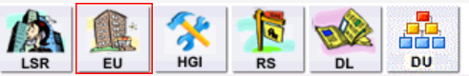  EU LOC ACCESS section:  - Enter 1 in LOCNUM field.  - Enter name of the end-user in NAME field.  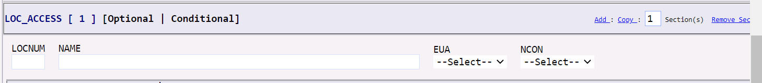

Step | Action
4 cont | EU Form Entry (continued)  EU LOC ACCESS INFO section:  - Enter local contact person in LCON.  - Enter local contact person telephone number in TEL NO.  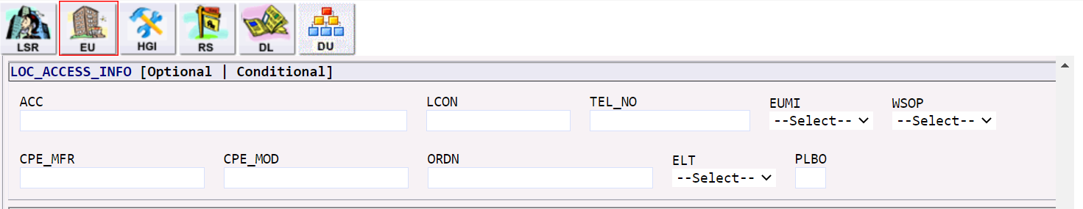  EU SVC ADDR GRP section:  - Click on Search Pre-Order.  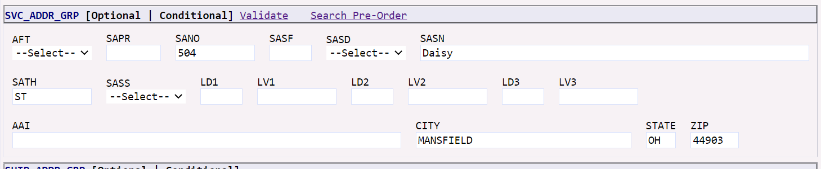

Step | Action
4 cont | EU Form Entry (continued)  EU SVC ADDR GRP section(continued):  - Select the saved Preorder related to this request and click on it.  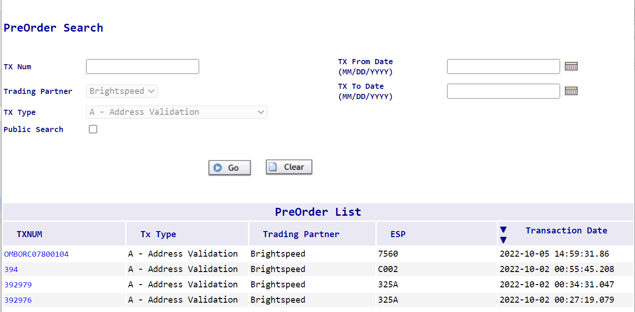  Result: The Preorder opens.  - Click on Prepopulate.  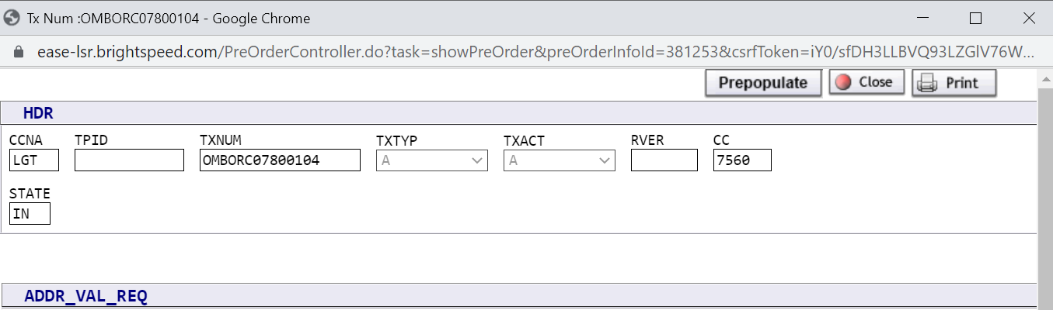

Step | Action
4 cont | EU Form Entry (continued)  EU SVC ADDR GRP section(continued):  Result: The EU SVC ADDR GRP pre-populates with valid address.
5 | Click on RS Form  RS ADMIN section:  - Enter 0001 in RSQTY field.  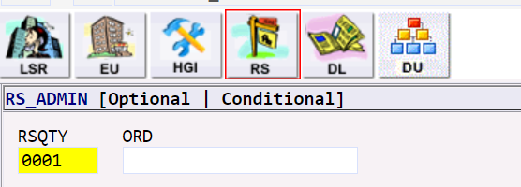  RS SVC DET section:  - Enter N in the TNS field.  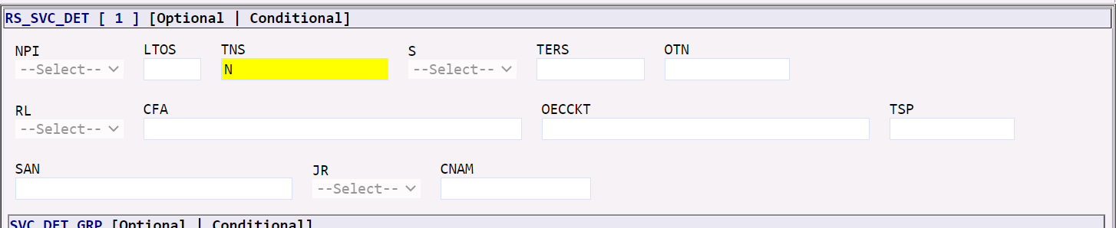

Step | Action
5 cont | RS Form Entry (continued)  RS SVC DET GRP section:  - Enter 01 in LOCNUM field.  - Enter 01 in LNUM field.  - Enter N in LNA field.  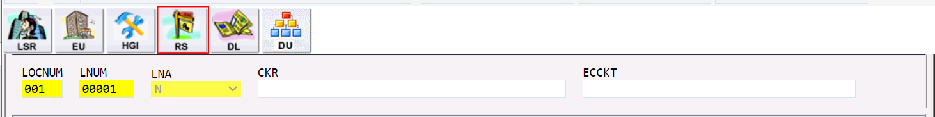  RS LINE RESTRICT 2 GRP:  - Enter NONE in PIC field.  - Enter NONE in LPIC field.  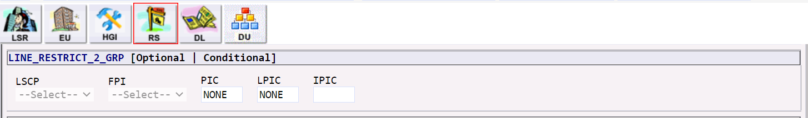  RS FEATURE GRP Section:  - Enter 5 in section(s).  - Click Add.  Result: You have 6 Feature fields available to be populated.

Step | Action
5 cont | RS Form Entry (continued)  Utilizing the WBSA External Comm Feature Code Spreadsheet, Enter FEATURE GRP [1] through [6]. NOTE: May not utilize all Feature Field. Will vary depending on Gateway/Modem and Static IP request.  RS FEATURE GRP [1] Section:  - Enter N in FA field.  - Enter NDT Line Feature Code in FEATURE Field.  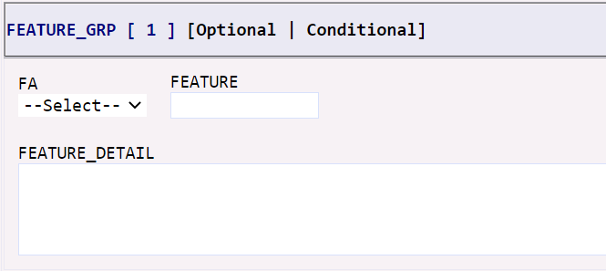  RS FEATURE GRP [2] Section:  - Enter N in FA field.  - Enter the speed Feature Code in FEATURE Field.  RS FEATURE GRP [3] Section:  - Enter N in FA field.  - Enter the install Feature Code in FEATURE Field.  RS FEATURE GRP [4] Section:  - Enter N in FA field.  - Enter the Gateway/Modem Feature Code related to the install choice in FEATURE Field.

Step | Action
5 cont | RS Form Entry (continued)  NOTE: FEATURE GRP [5] and [6] can be used for ordering Static IP. If not ordering Static IP, go to next step 6.  RS FEATURE GRP [5] Section:  - Enter N in FA field.  - Enter Static IP Address Feature Code FEATURE Field.  RS FEATURE GRP [6] Section:  - Enter N in FA field.  - Enter Static IP Feature Code for the number of IPs requested in FEATURE Field.
6 | In the top right corner of the LSR:  - Click on the Save ICON.  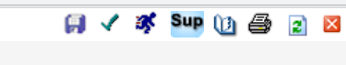  - Click on Validate ICON.

Step | Action
6 cont | - Correct any errors that might have returned. Errors must be corrected before PON can be submitted.  Example of ErrorCode List:  - Click on Submit ICON.  Result: STATUS will show Submitted.  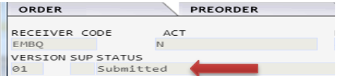  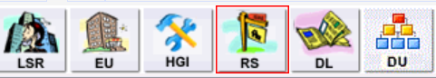  - Click on the X in the top right hand corner.  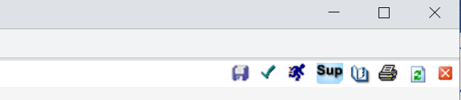

Step | Action
 | Result: Home Page/Status Screen will display.

EASE VFO LSR Logout

EASE VFO Logout | Follow the steps below to Logout of EASE VFO LSR.  Step Action  1 Click LOGOUT in the top right hand corner. 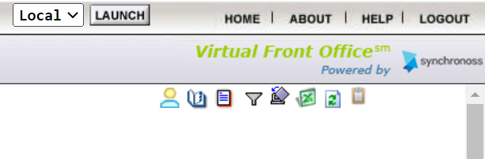 Result: Login screen displays. 